Day 5 – Business Process & Data Modeling
Project
ProcurAgent – AI-Powered Automotive Procurement & Supplier Risk Management System
Day 5 Summary
Day 5 focused on understanding how ProcurAgent’s business information is structured and stored. The day covered database schema, master records, domain modeling, ER diagrams, primary and foreign keys, business rules, data flow, and API/data dependencies.

Concepts Learned
1. Database Schema
A database schema defines the structure of data stored in the system, including tables, fields, relationships, and constraints.
For ProcurAgent
- Suppliers
- Components
- Procurement Requirements
- RFQs
- Quotations
- Inventory
- Supplier Performance
- Risk Assessments
- Recommendations
- Purchase Orders

2. Master Records
Master records contain the basic information required throughout the system.
Supplier Master
- Supplier ID
- Supplier Name
- Location
- Contact Information
- Capacity
- Quality Qualification
- Supplier Status
Component Master
- Component ID
- Component Name
- Category
- Unit
- Criticality

3. Domain Model
A domain model represents important business entities and their relationships.
ProcurAgent Domain Flow
Customer Order → Production Plan → BOM → Component → Procurement Requirement → RFQ → Supplier → Quotation → Risk Assessment → Recommendation → Approval → Purchase Order → Delivery

4. ER Diagram
An Entity Relationship Diagram (ER Diagram) represents database entities, their attributes, and relationships.
Important Relationships
- One Procurement Requirement → Many RFQs
- One RFQ → Many Quotations
- One Supplier → Many Quotations
- One Supplier → Many Risk Assessments
- One Recommendation → Approval
- One Approval → Purchase Order

5. Primary Key & Foreign Key
Primary Key (PK)
Uniquely identifies a record.
Example:
Supplier_ID (PK)
Foreign Key (FK)
Connects one table to another.
Example:
Quotation.Supplier_ID (FK) → Supplier.Supplier_ID (PK)

6. Business Rules
Business rules define conditions that control how ProcurAgent operates.
- A quotation must belong to a valid supplier and RFQ.
- Risk assessment should use available supplier-performance signals.
- A new supplier without sufficient historical evidence should not receive a falsely high-confidence assessment.
- High-risk suppliers should generate alerts.
- Important AI recommendations require human approval.

7. Data-to-Database Flow
Supplier / Procurement Data
↓
Data Processing
↓
PostgreSQL Database
↓
AI Agent Workflows
↓
Risk Assessment
↓
Recommendation / Alert
↓
Dashboard

8. API & Data Dependencies
Supplier API
- Add supplier
- View supplier
- Update supplier
- View performance
Procurement API
- Create procurement requirement
- Create RFQ
- View RFQs
- Compare quotations
Risk API
- View risk
- View risk signals
- View alerts
- Trigger re-analysis

Diagram / Picture Space
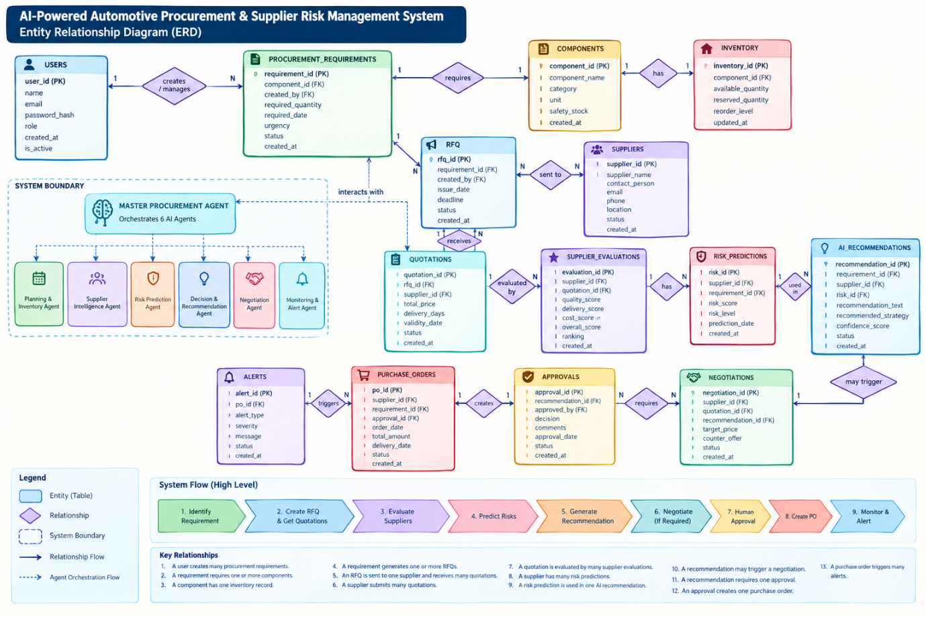

Day 5 Learning Outcome
By the end of Day 5, the concepts of database schema, master records, domain model, ER diagrams, primary keys, foreign keys, relationships, business rules, data flow, and API/data dependencies were understood.
Key Takeaway
Business Entities → Database Schema → Domain Model → ER Diagram → PK/FK → Relationships → Business Rules → Data Flow → APIs

